Project Design Phase-II
Data Flow Diagram & User Stories

Date | 5 July 2026
Team ID
Project Name | Nutrition Assistant
Maximum Marks | 4 Marks

Data Flow Diagrams:
A Data Flow Diagram (DFD) is a traditional visual representation of the information flows within a system. A neat and clear DFD can depict the right amount of the system requirement graphically. It shows how data enters and leaves the system, what changes the information, and where data is stored.
Example: DFD Level 0 (Industry Standard)
Example: (Simplified)
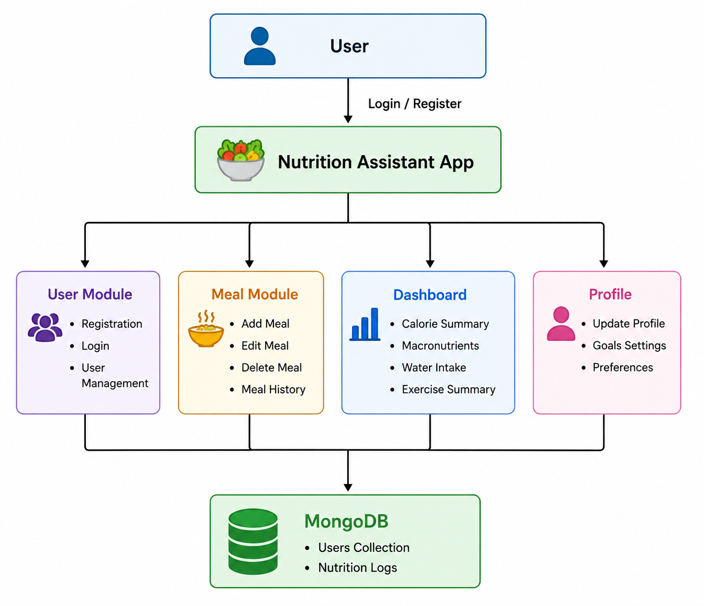



User Stories
Use the below template to list all the user stories for the product.
User Type | Functional Requirement (Epic) | User Story No | User Story / Task | Acceptance Criteria | Priority | Release
Customer (Web User) | Registration | USN-1 | As a user, I can register using my name, email and password. | User account is created successfully. | High | Sprint-1
Customer (Web User) | Login | USN-2 | As a user, I can log in using my registered email and password. | User is redirected to the dashboard after successful login. | High | Sprint-1
Customer (Web User) | Dashboard | USN-3 | As a user, I can view my daily calorie and nutrition summary. | Dashboard displays updated calorie and macro values. | High | Sprint-1
Customer (Web User) | Add Meal | USN-4 | As a user, I can add breakfast, lunch, snacks and dinner. | Meal is saved successfully and dashboard updates. | High | Sprint-2
Customer (Web User) | Nutrition Tracking | USN-5 | As a user, I can track protein, carbohydrates and fat. | Macronutrients are calculated correctly. | High | Sprint-2
Customer (Web User) | Water Intake | USN-6 | As a user, I can record daily water intake. | Water intake is updated successfully. | Medium | Sprint-3
Customer (Web User) | Exercise Tracking | USN-7 | As a user, I can record exercise details. | Exercise history is saved successfully. | Medium | Sprint-3
Customer (Web User) | Profile | USN-8 | As a user, I can update my weight, height and calorie goal. | Profile changes are saved successfully. | High | Sprint-4
Customer (Web User) | Reports | USN-9 | As a user, I can view nutrition history and progress. | Reports display accurate data. | Medium | Sprint-4
Customer (Web User) | Logout | USN-10 | As a user, I can securely log out of the application. | User session ends and redirects to Login page. | Low | Sprint-4

